**In Class Exercise**

**Inheritance & Polymorphism**

Consider the following inheritance hierarchy that presents a quiz to the user with different kinds of questions:

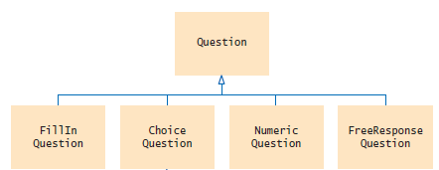

**Question Class**

The main task in this class is to the print the question and answer to the screen

* Two String member variables to represent the text of the question and the answer
* Default constructor
* Overloaded constructor which takes the question (String) as a parameter
* setAnswer method which sets the answer to the correct answer. It takes one String parameter
* checkAnswer method which takes a String as a parameter representing the answer given by the user. This returns true if the answer is correct, otherwise false
* display method which prints out the question

**ChoiceQuestion**

Subclass of Question

1 additional member (ArrayList) to store the list of choices (String)

Constructor which takes one parameter representing the question and calls the superclass constructor to set the question text. ArrayList should also be initialised.

addChoice method which sets the answer when the correct choice is added. It takes two parameters representing the choice (String) and a Boolean value representing the correct/incorrect answer

display method displays the question text, then the choices

**Test Class**

Construct two different questions and present them to the user

Define an array of type question which can hold 2 questions

Create a Question object for the following:

Question “Who was the inventor of the Java language?” and add it to the array

Answer “James Gosling”

Create a ChoiceQuestion object for the following:

“In which country was the inventor of Java born?”

Answers:

Australia false

Canada true

Denmark false

United States false

Use a for loop to:

Call the display method to display the questions to the user

Accept the answer from the user and call the checkAnswer method

**Sample Output**

Who was the inventor of the Java language?

Your answer:

James Gosling

true

In which country was the inventor of Java born?

1): Australia

2): Canada

3): Denmark

4): United States

Your answer:

2

true